POLITICAL JUGGERNAUTS
A Quantitative Analysis Of Candidates In The 2019 Lok Sabha Elections
1.INTRODUCTION
  - Overview
The Lok Sabha is composed of representatives of people chosen by direct election on the basis of Universal Adult Suffrage. The Constitution of India allows for a maximum of 550 members in the House, with 530 members representing the States and 20 representing the Union Territories. The 17th Lok Sabha was formed by the members elected in the 2019 Indian general election. Elections, all across India, were conducted in seven phases from 11 April 2019 to 19 May 2019 by the Election Commission of India.
  - Purpose
Project goals,Success metrics,Stake holders and roles,Budget Milestones and deliverables,Timeline and schedule,Project commun

2.Problem Defenition &Design Think

2.1 EMPATHY MAP

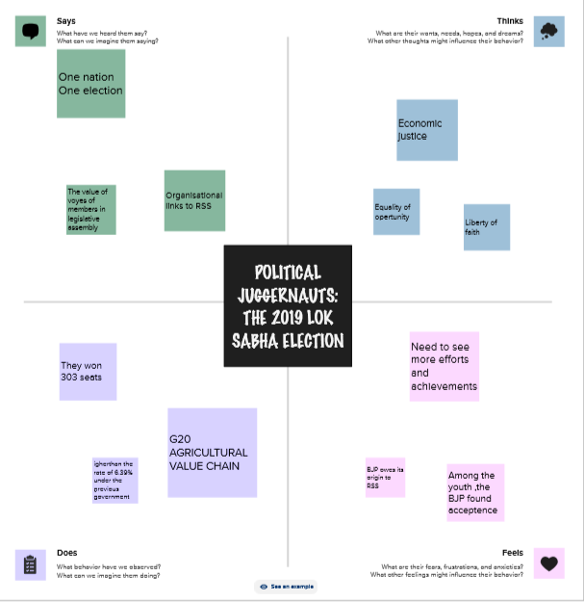

2.2 IDEATION&BRAINSTROMING MAP
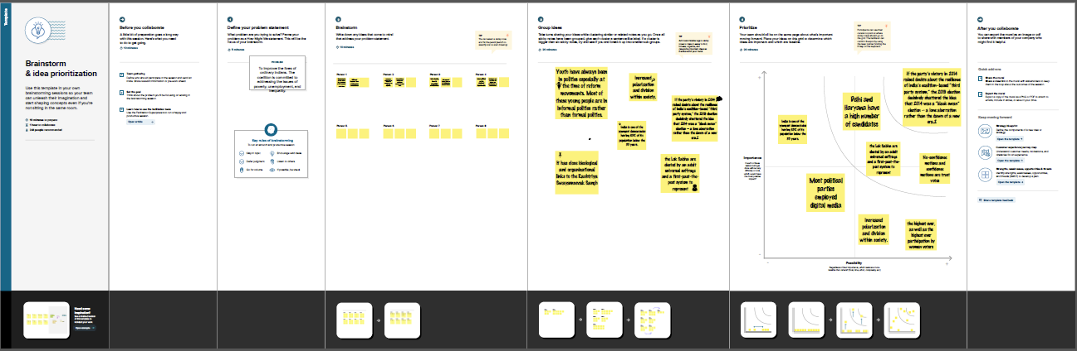

3.RESULT
DASHBOARD
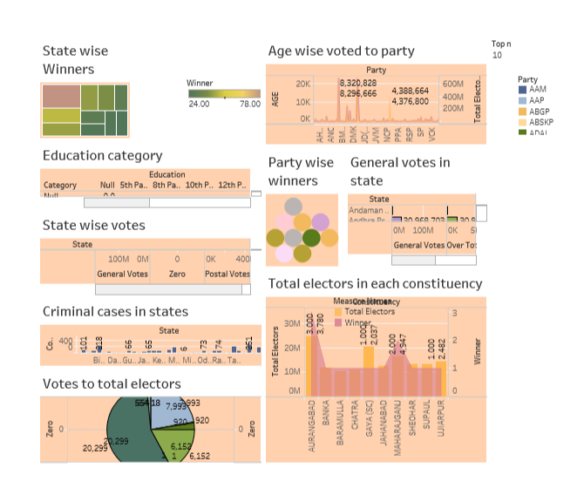
STORY:
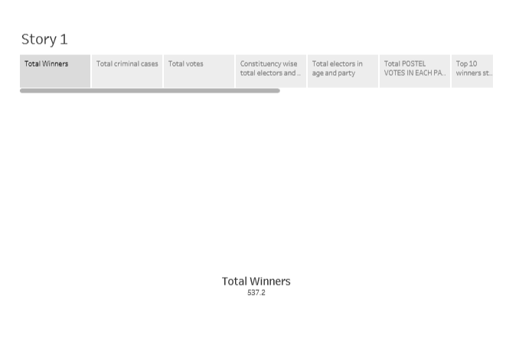

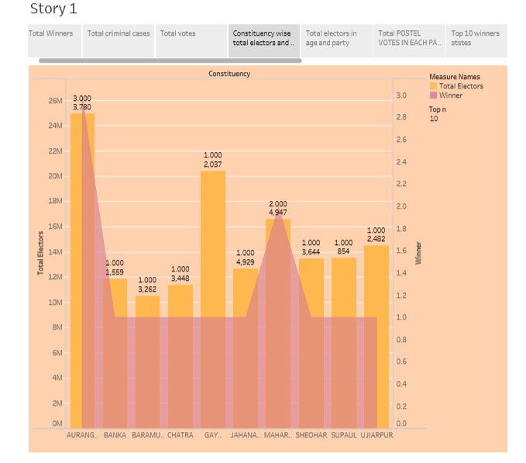
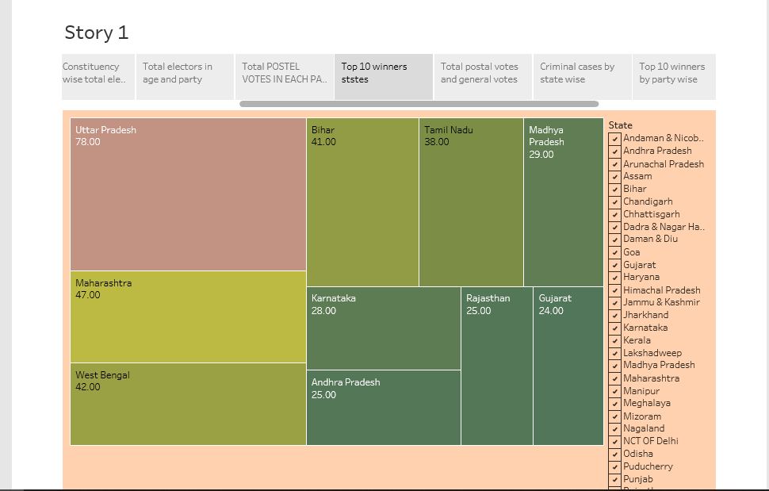
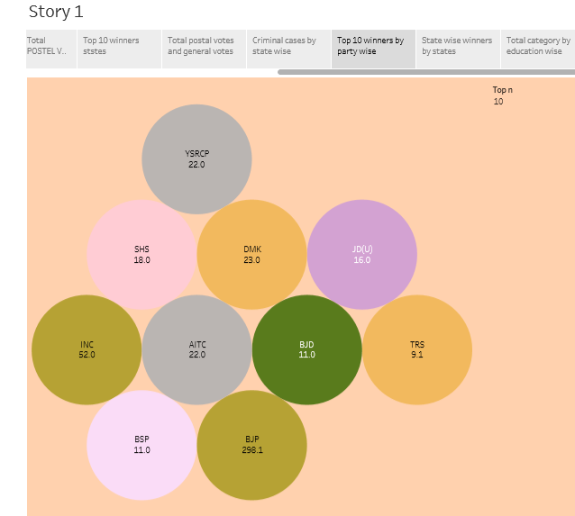
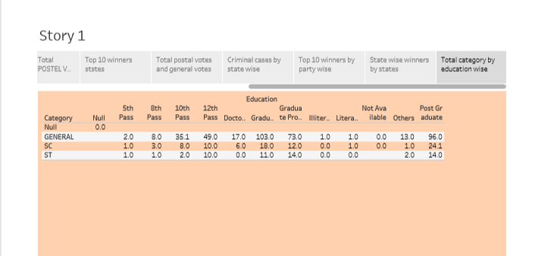
4.ADVANTAGES & DISADVANTAGES
ADVANTAGES:
1.Influence and power
Being a social political juggernauts often means having a significant influence over police opinion and govern ment decisions
2.MOBILIZATION : Juggernauts can mobilize a large number of supports quickly making them effective at rallying people for are social moments

DISADVANTAGES:
Lack of accountability: Powerfull social and political juggernauts can some times act without accountability,making decisions that may not be in the best interest of the general population

5.APPLICATIONS :
1.YOUTH ENVOLVEMENT
Encouraging young people to engage in politics and run for office
2.WOMENS PARTICIPATION :
Promoting gender equality gender and increasing the parcipation of women in the electoral process.
6.CONCLUSION:
“In the lok sabha election the people have exercised their democratic right to elect their representatives .The result reflect the will of the electorate and serve as a testament to the vibrancy of our democracy . It is crucial to analyze
These outcomes to understand the political landscape and shape future policies governance decisions based on the peoples mandate “.

7. FUTURE SCOPE:
1. Digitalization : With the increasing use of technology election may become more digitized ,improving voter registeration ,polling , and result dissemination .
2. Reginal Dynamics :
Reginal parties and issues will countinue to have an impact ,potentially leading to more diverse coualitions and alliance.

